Name: Shubham Shashwat
Roll: 244CA053

1. List all students with a total credit count of 0.

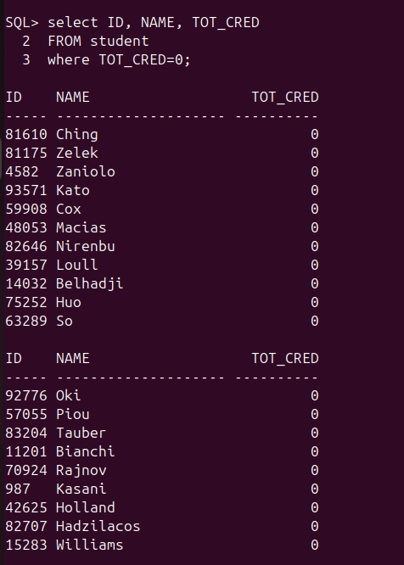

2. Find the names of all courses offered by the "Physics" department.
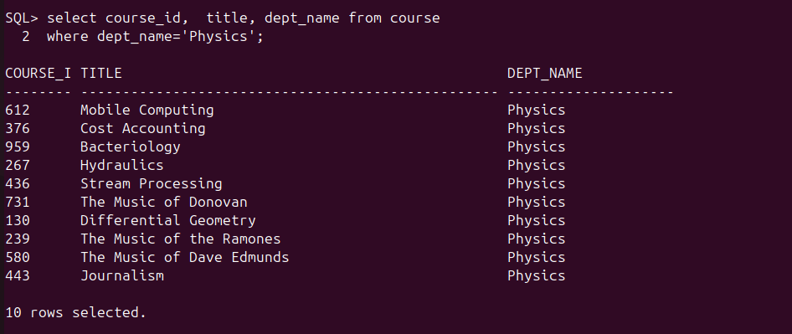
3. Retrieve the names of all instructors who earn exactly ₹50,000.
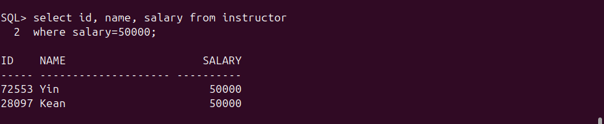
4. List all classrooms with a capacity of exactly 100.

5. Find the total number of courses offered in the "Spring" semester.
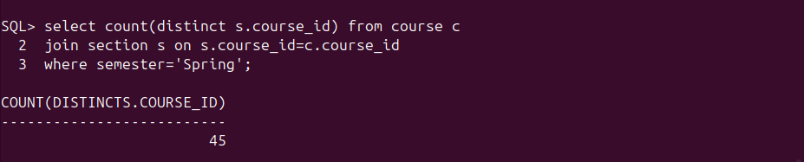
6. List all students who have taken exactly 30 total credits.
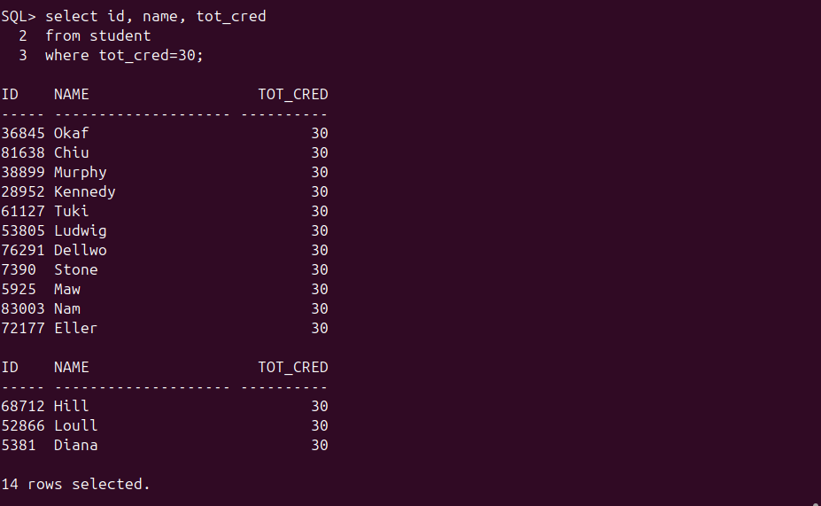

7. Find the names of all courses offered by the "Physics" department.
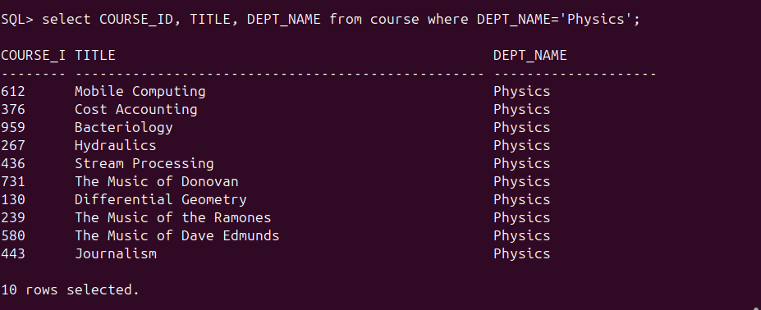
8. Retrieve the names of all instructors who earn more than ₹100,000.
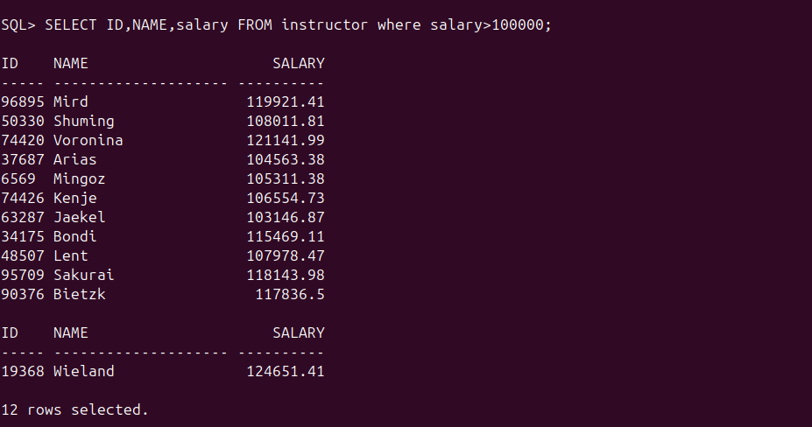
9. List all classrooms located in the "Taylor" building.
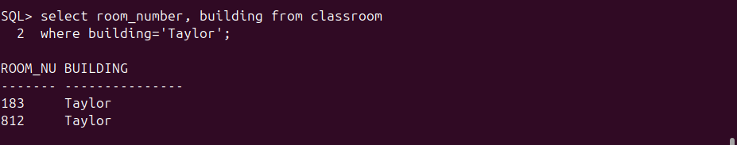
10. Find the total number of courses offered in the "Fall" semester.

11. List all students who have taken courses with a grade of "C" or lower.

select s.id, s.name,t.grade from student s
join takes t on t.id=s.id
where grade in ('C+', 'C-', ‘C’);
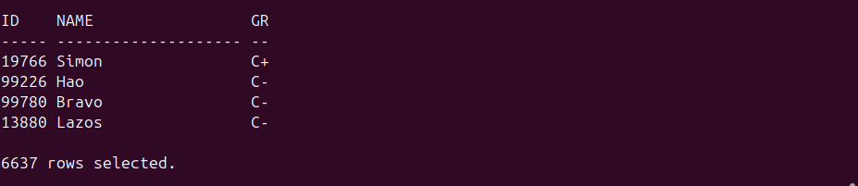
12. Retrieve the names of instructors who have taught in the "Fall" semester of 2003.
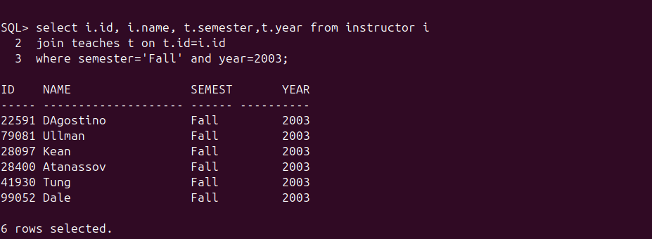
13. Find the average capacity of classrooms in each building.
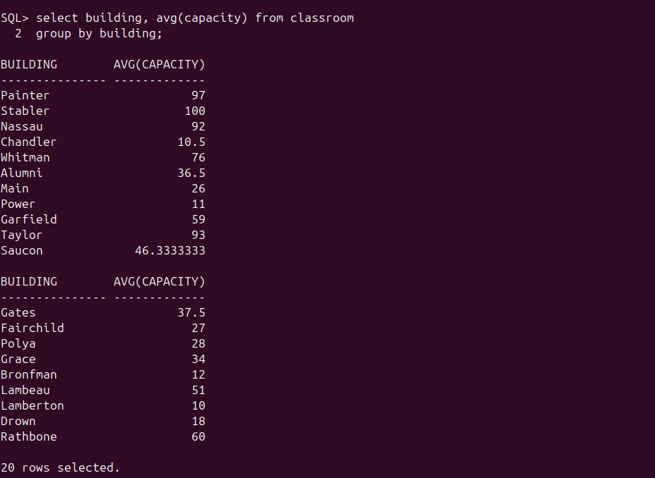
14. List all courses that have more than 3 credits.
select course_id, title from course
where credits>3;

15. Retrieve the names of students who have taken courses in the "Taylor" building.
SQL> select s.id, s.name, b.building
from student s
join department b on s.dept_name=b.dept_name
where b.building='Taylor';
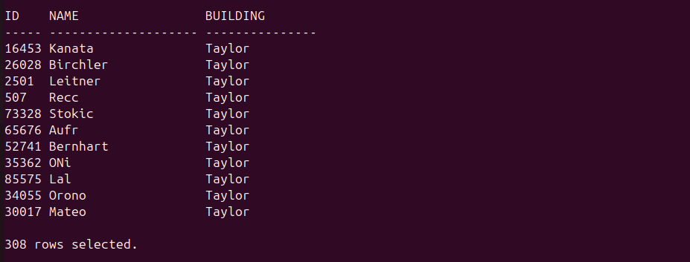
16. Find the total number of students advised by each instructor.
select I_ID, count(distinct S_ID) as Number_of_students
from advisor
group by I_ID;
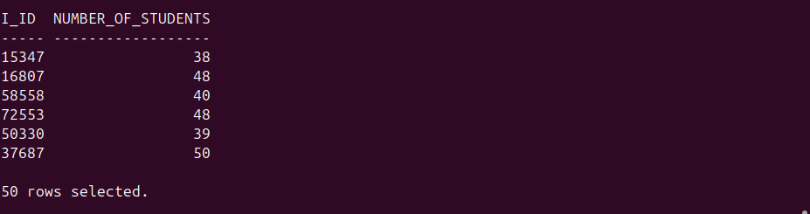
17. List all sections that do not have a classroom assigned.
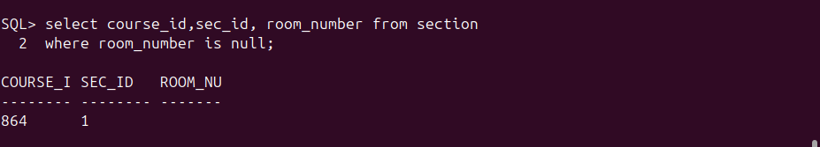
18. Retrieve the names of students who have taken courses with the highest number of
credits.
select distinct name
2 from student natural join takes natural join course
3 where credits = (select max(credits) from course);


19. Find the departments with the highest average instructor salary.
select dept_name, avg_salary from
2 (select dept_name, avg(salary) as avg_salary from instructor group by dept_name) avg_table
3 where avg_salary = (select max(avg(salary)) from instructor group by dept_name);
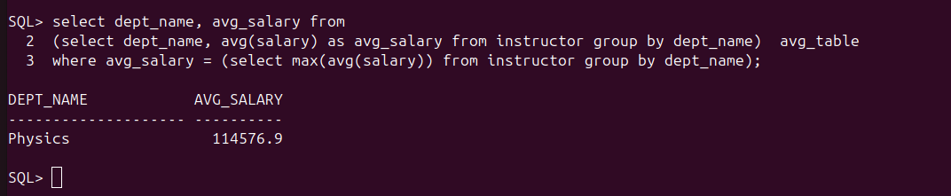
20. List all courses that have been taught by more than one instructor.
SQL> select course_id, counter from
2 (select distinct(course_id), count(id) as counter from teaches group by course_id) cno
3 where counter>1;
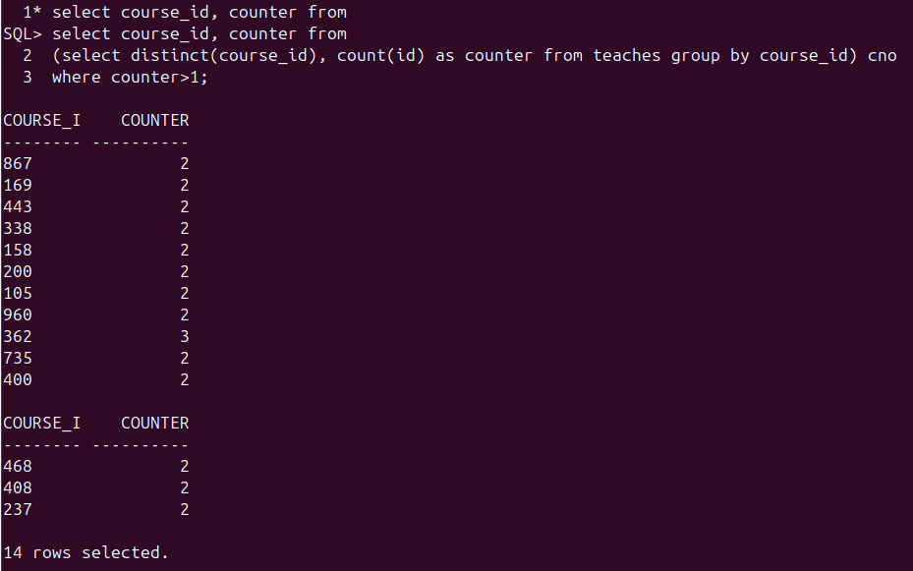
21. List all students who have taken courses with a grade of "A" in the "Fall" semester of
2007.
SQL> select s.id, s.name from student s join takes t on t.id=s.id
2 where t.semester='Fall' and t.grade='A ' and t.year=2007;

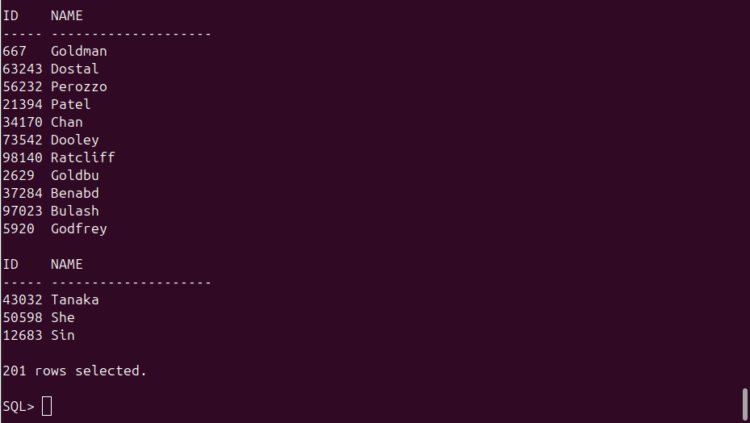
22. Retrieve the names of instructors who have taught in the "Spring" semester of 2007.
SQL> select i.id, i.name from instructor i join teaches t on t.id=i.id
2 where t.semester='Spring' and year=2007;

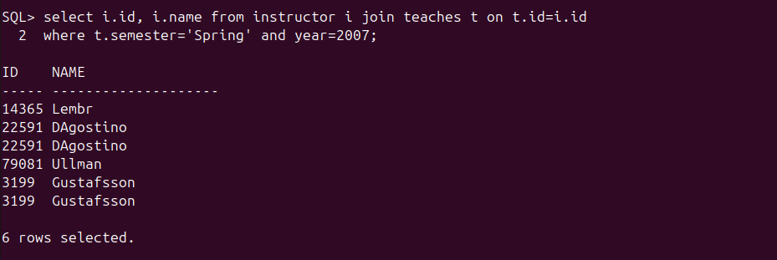

23. Find the average number of students enrolled in each course.
SQL> select avg(avg_std) as average_student_per_course from
2 (select c.course_id, c.title, count(t.id) as avg_std from course c join takes t on c.course_id=t.course_id group by c.course_id, c.title) avgs;
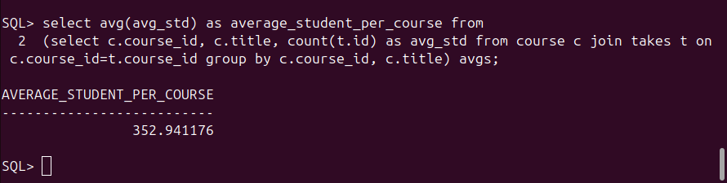
24. List all courses that have exactly 4 credits.
SQL> select course_id, title from course where credits=4;
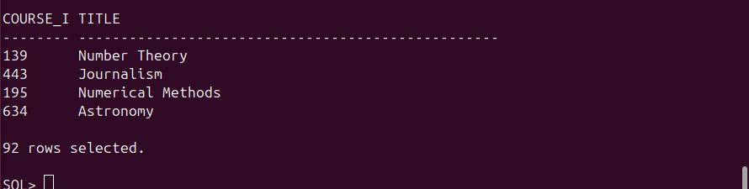
25. Retrieve the names of students who have taken courses in the "Taylor" building.
SQL> select distinct(s.name) from student s join takes t on s.id=t.id join department d on s.dept_name=d.dept_name
2 where d.building='Taylor';

26. Find the total number of sections taught by each instructor.
SQL> select t.id, i.name, count(distinct(sec_id)) from teaches t join instructor i on i.id=t.id
2 group by t.id, i.name;
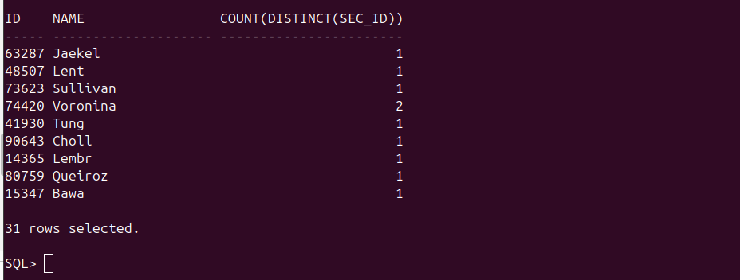
27. List all sections that are held in rooms with a capacity of less than 50.
SQL> select distinct(sec_id) from section join classroom on section.building=classroom.building
2 where capacity<50;
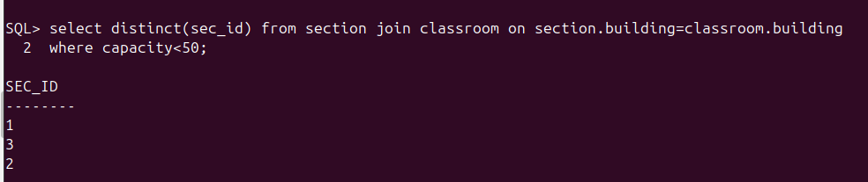
28. Retrieve the names of students who have taken courses with the lowest number of
credits.
select distinct(s.name) from student s join takes t on s.id=t.id join course c on t.course_id=c.course_id
2 where credits=(select min(credits) from course);

29. Find the departments with the lowest average instructor salary.
30. List all courses that have been taught by only one instructor.
31. Find the students who have taken courses with every instructor in the university.
32. Retrieve the names of instructors who have taught courses in all available semesters.
33. List all courses that have been taught in every building.
34. Find the students who have taken the most number of courses in a single year.
35. Retrieve the names of students who have taken courses with overlapping time slots in
the same semester.
36. List all courses that have been taught by the same instructor in consecutive semesters.
37. Find the departments where the total student credits are less than the department
budget.
38. Retrieve the names of students who have taken courses with every time slot.
39. List all courses that have been taught in every year.
40. Find the students who have taken the most number of courses with the same instructor.
41. Find the students who have taken courses from at least 3 different departments.
42. Retrieve the names of instructors who have taught the same course in consecutive
years.
43. List all courses that are prerequisites for exactly 2 other courses.
44. Find the departments where the total student credits are equal to the department budget.
45. Retrieve the names of students who have taken courses with every time slot in a single
semester.
46. List all courses that have been taught in every building except one.
47. Find the students who have taken the most number of courses in a single department.
48. Retrieve the names of instructors who have taught courses in all available time slots.
49. List all students who have taken courses with overlapping time slots in different
semesters.
50. Find the courses that have the lowest enrollment across all semesters.

